The caller would like to book a P&O Cruise holiday under the ‘**SHINE MEMBER DISCOUNT SCHEME’** and has quoted “**HCZ**”

Ask if the agent is signed up to Shine Rewards Club and obtain their full name, ABTA number, and Shine Rewards Club username.

Provide this information to the Senior Support Channel, and a senior will confirm the agent is signed up to Shine Rewards Club and continue quoting whilst waiting for a response.

Using AVAL, enter ABTA “000TADIS” in the ABTA field and press enter until you reach the Fare Pricing Page and quote as usual.

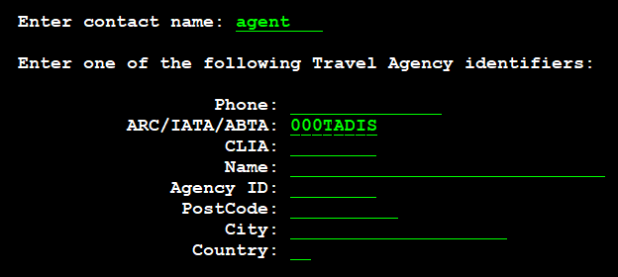

Once the Senior Support have confirmed the agent is Signed up to Shine Rewards Club, continue with the booking as usual.

If the travel agent has not signed up to Shine Rewards Club, they will need to register first and have their account verified prior to making the booking.

Once the booking has been made add the agents name and ABTA number on the remarks line and take the deposit.