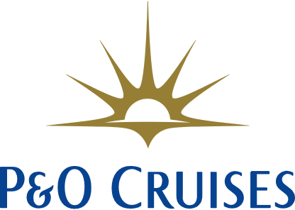

Shine Member Discount

Internal - FAQ

|  |  |
| --- | --- |
| **Question** | **Answer** |
| Who is eligible? | The Shine Member discount promotion is available to any active travel agent partners registered to Shine Rewards Club. |
| The travel agent used to be a member of Shine Rewards Club are they still eligible? | To benefit from the promotion, the travel agent needs to be active member of Shine Rewards Club and registered to trade with P&O Cruises. If the guest used to be a member and no longer works within the industry, they will not be eligible. If the travel agent has moved agencies and has had a profile in the past and is registered to trade with P&O Cruises, they can update their details or e-mail [info@shinerewardsclub.com](mailto:info@shinerewardsclub.com) so that we can deactivate their old account. |
| Can the travel agent book more than one cabin and benefit from the 10% discount on both including friends and family within their traveling party? | We are rewarding Shine Rewards Club members with a fantastic discount of 10% which is exclusive to travel agents only and applies to the booking and cabin they are traveling in.  Friends and family traveling with them can benefit from great value on P&O Cruises holidays and offers, however, they are excluded from this promotion. |
| Can the travel agent transfer their booking? | Yes, they can. Standard booking terms & conditions apply. |
| Can the travel agent cancel their booking? | Yes, they can. Standard booking terms & conditions apply. |
| Can the travel agent make a name change on their booking? | Yes, they can. If the travel agent on the booking calls to make a name change and **they are no longer travelling**, the booking will need to be amended and the travel agent's 10% discount will be removed. The price will revert to the price at the time the booking was made without the discount.  Full payment of additional deposits or outstanding balances will need to be made at this time. Please contact a Senior Advisor or TL to process the name change.  For any other name changes on the booking, standard booking terms and conditions apply. |
| Can the travel agent access their booking on My P&O Cruises once made? | Yes, they can. My P&O Cruises features will be available as usual and they can make dining reservations, book entertainment and shore experiences as well as purchase drinks packages. |
| Can guests make payments for their outstanding balance on My P&O Cruises? | Yes, they can. Payments can be made on My P&O Cruises for outstanding balances. They don’t need to call us to make a payment. |
| Can the travel agent purchase the drinks package at the time of booking? | Yes, they can, however this promotion is excluded from the 10% discount. The guests will also be able to access My P&O Cruises and benefit from the pre-cruise discount via the pre-cruise portal and purchase the drinks package after the booking has been made. |
| Can the travel agent claim On-board Shine Perks (Captain, Staff Captain, Commodore) benefits to their booking? | We are rewarding agents with a 10% discount and cruises of their choice sailing up to 31 March 2025 and the On-board Shine Perks benefits are not combinable with this offer.  The great news is that they can visit the “Holiday with Shine” page on Shine Rewards Club and make use of the On-board Shine Perks on cruises already made outside of this promotion. |
| Can the discount be applied to bookings already made? | The discount applies to new bookings only departing on or before the 31 of March 2025. |
| Can the travel agent use Shine Rewards Club points towards the deposit or balance of their holiday? | Our “Holiday with Shine” rewards scheme provides travel agents with the opportunity to make a booking using shine points, however, this is not combinable with the 10% Shine Member Discount. |
| Can the travel agent retain the 10% discount if they leave travel? | To benefit from the promotion, the travel agent needs to be an active member of Shine Rewards Club and registered to trade with P&O Cruises. If the guest used to be a member and no longer works within the industry, they will not be eligible. |
| Can the travel agent book consecutive cruises with an additional 10% back-to-back discount? | Yes, travel agents are eligible to book back-to-back cruises and still benefit from the Shine Member Discount. |