**EE Grade cabins – Photographs**

**EE Grade – C002 ADA Cabin – Shower only**

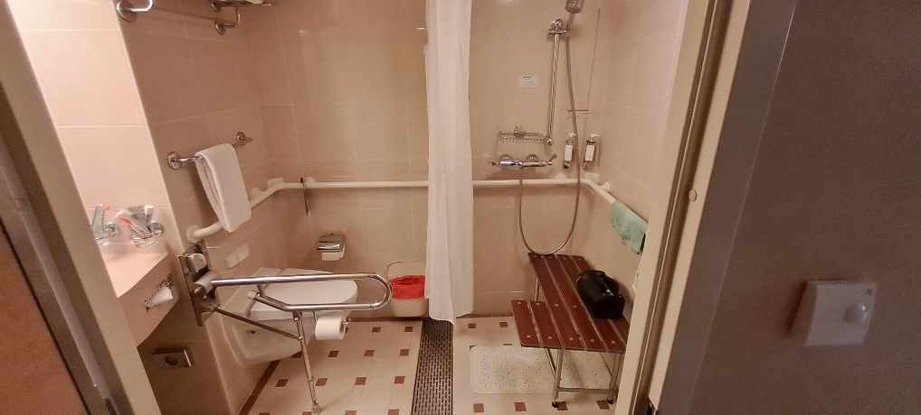

**EE Grade – E173 Balcony Cabin – Bathtub only**

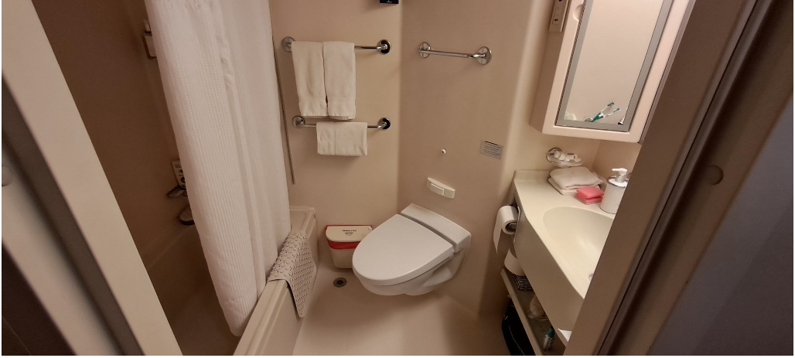

**EE Grade – E183 Balcony Cabin – Shower only**

