# Which brands do the Ceremonies at Sea team look after?

* P&O Cruises
* Cunard

# Responsibilities before, during and after the ceremony event?

* Ceremonies at Sea – The team will provide all information surrounding the event itself, they will help and support the guest with planning every bit of detail for their special day. All plans are sent directly to the ship with a final copy to the Event Manager onboard.
* The Events Manager is responsible for the overall preparation and delivery of the services standards within the Dedicated venue or Ivory Suite and to request the necessary support to all departments onboard to arrange all plans for ceremony guests.
* The Captain will conduct the ceremony at sea however, in an event which the Captain cannot perform duty, the Deputy Captain will be responsible to set-in and conduct the ceremony at sea.
* After the event has taken place and the guest is home. The Ceremonies at sea team will reach out to the guest to get feedback as well as sending the guest their marriage certificate.

# Weddings, Commitment Ceremonies and Renewal of Vows on board the following P&O cruises and Cunard Vessels:

P&O Cruises:

* **Arcadia**
* **Azura**
* **Ventura**
* **Aurora**
* **Britannia –** Non-Legal Weddings
* **Iona –** Non-Legal Weddings
* **Arvia –** Non-Legal Weddings

Cunard:

* **Queen Mary 2**
* **Queen Victoria**
* **Queen Elizabeth**
* **Queen Anne**

# What ceremony time slots can I book at sea for a guest?

* **P&O Cruises time slots**: 11am, 2pm and 3:30pm (Iona we only offer 2pm and 3:30pm).
* **Cunard time slots:** 11am or 3:30pm

# Can a guest change their ceremony date and time after booking?

* Yes. Please speak to your CCO senior or Ceremonies at Sea team to check the calendar availability before amending the date/time.

# What is the maximum number for guest attendance?

* 60 for P&O cruises
* 40 for Cunard

Any additional guests please speak to Ceremonies at Sea team as we will be required to check venue capacity.

# How much is the guest attendance fee?

* For all ceremonies 10 guests are included in the package.
* Every multiple of 10 additional guests attending a P&O cruises ceremony it is £100 admin fee and Cunard $120 admin fee.
* The payment for guest total number will be due after the completion of filling out the planning form.

# How long does a ceremony at sea last for?

* 45 minutes – 1 hour

# When will I receive my planning forms?

* The planning form will automatically be sent to the guest via email 4 months prior to the guest sailing date.
* The guest will need to fill out the document and send back to Ceremonies at sea via email or post it to Carnival House. The post-room is checked every Thursday.

# What is the cruise duration which the guest needs to book to secure a ceremony at sea?

* Ceremonies (Weddings, Commitments, and Renewal of vows) will be available on sea days for 7-night sailings of more.
* Some short sailings are available to book however, please speak to your Senior or Ceremonies at sea team.

# Do I need a booking reference to book a ceremony?

* The Sonas system can hold a ceremony date for a guest without a polar booking for 7 working days.
* To secure the booking, the guest will need a polar booking reference for example, XJK562 because the ceremony will be added in SSV section for payment. Please remember that the cruise booking, and ceremony booking are two separate things therefore, a deposit will be required for both.

# What is the deposit amount for a Ceremony at Sea?

* Wedding package, Just The Two Of Us, Commitment Ceremony is 25% deposit at time of booking.
* Renewal of Vows is full payment at time of booking.
* For Cunard ceremonies, same rules apply as per the above however, this will be charged in dollars and then converted into pounds. Exchange rate depends on who the guest banks with.

# The ceremony date and cruise are available, how do I book?

* Your ceremony booking is now on hold in the Sonas system by your Senior. The ceremony will show on hold with your name and hold date and will be tagged as Date on hold.
* Please send an email to the Ceremonies inbox team notifying them of the holding ceremony to follow up and confirm the event and collect the deposit. [**ceremonies@carnivalukgroup.com**](mailto:ceremonies@carnivalukgroup.com)

# When will I receive my marriage certificate?

* The marriage certificate is sent from our Bermudan registry to Carnival House in Southampton which is then sent via post to the address given at time of signing the certificate onboard and stated on your intended marriage license.
* This process can take up to 16 weeks from the guest disembarkation date.
* The Ceremonies at sea team will contact the guest via telephone or email to up date the guest once their marriage certificate has been received.

# Priority Boarding:

* Only the ceremony couple, i.e Bride and Groom will receive priority boarding.
* This is only for sailings from Southampton.
* The guest will be issued a boarding time by P&O Cruises which they will need to adhere to as it is an allocated E-Ticket.
* When the guest arrives at the cruise terminal at Southampton, please make advise the guest to make themselves known at the information desk where they will then be directed to the Priority Boarding gate. Unfortunately, the guest will not have this noted on the P&O Cruises E-Ticket as we use a different booking system and do not have access to change this.

# Does P&O Cruises and Cunard offer preshow around tours to Bride & Groom?

* At this moment of time, we do not offer preshow around tours for ceremony guests.

# Does Carnival UK offer same sex marriages at sea?

* At present, we’re unable to offer our Weddings at Sea packages to same-sex couples.
* This is because four of our ships are registered in Bermuda, where same-sex couples can’t legally marry. However, the following ships Britannia, Iona and Arvia are registered in the UK, but we currently don’t offer Weddings at Sea on them; however, this is something we’re looking into.
* An alternative is a commitment ceremony. It’s very similar to a wedding but doesn’t have the legalities, so you’d need to get married before or after your cruise. Some couples prefer this option as it means you’re not restricted by legal vows and can be as creative as you want to be with them. (It also helps with those pre-wedding jitters it's likely that you've already made the commitment – now it’s just time to celebrate!)
* Our commitment ceremony package includes everything else a Wedding at Sea package does, including our outstanding service and seamless process so that all of the little details shine without the stress of organising them.

# When will the ceremony guest get to meet the Event Manger onboard?

* A Welcome Letter – The Welcome Letter invites the ceremony couple to meet the Shipboard Wedding Coordinator at the Reception / Purser Office at a specified time to go through all the Wedding preparations. The Shipboard Wedding Coordinator is to contact the couple if s/he has not heard from them. The Welcome onboard letter will be delivered to the suite/cabin / stateroom prior to embarkation.

# Ceremony party benefits?

* Ceremony party benefits for onboard credit is applied 2-3 weeks prior to sailing date.
* Ceremony party benefits are applicable for parties of 16+ Passengers, booked across a minimum of 8 cabins. Bookings must be made under the 'Select Fare' or 'Early Saver' .
* This will only be applied by the Ceremonies at sea team, 2-3 weeks before the sailing. This will not be actioned a year or so before, due to T&C requirements.

**P&O Cruises:** For cruises of 7-11 nights in duration:

• Passengers 1&2 will receive £25pp onboard credit.

• The bride and Groom will receive £50pp onboard credit.

• This is in addition to any onboard credit given at the time of booking.

**P&O Cruises:** For cruises of 12+ Nights in duration:

• Passengers 1&2 will receive £50pp onboard credit.

• The bride and Groom will receive £100pp onboard credit.

• This is in addition to any onboard credit given at the time of booking.

**Cunard:** For cruises of 7-11 nights in duration:

• Passengers 1&2 will receive $40pp onboard credit.

• The bride and Groom will receive $80pp onboard credit.

• This is in addition to any onboard credit given at the time of booking.

**Cunard:** For cruises of 12+ Nights in duration:

• Passengers 1&2 will receive $75pp onboard credit.

• The bride and Groom will receive $150pp onboard credit.

• This is in addition to any onboard credit given at the time of booking.

***Terms & Conditions***

All bookings can be made up until the date of sailing (Except Bride & Groom as official paperwork needs to be completed prior to the wedding). A minimum of 16 heads ( lower berths only). Combinable with Cunard Fare or P&O Select Fare and Early Saver only. Benefits will only apply when minimum numbers have been reached. Deposits required at time of booking. Standard booking conditions apply. All bookings must be linked in Polar.

# Ceremony party benefits for cabin?

1 Free Refund Cabin:

* 1 free cabin for every 20 cabins booked, maximum of 3 free cabins per group.  Cheapest cabin refunded at time of sailing.
* This request can only be actioned when the sailing has taken place. Please email Ceremonies at sea team to action.
* You will need to check each fare of the whole group booking in polar and refund the reference which has the cheapest / lowest fare to the wedding couples booking reference.

# Where will be my reception meal after the ceremony?

* P&O Cruises – Once the guest has received their planning form, they will be able to see all options available to them to select.
* Cunard – Once the guest has received their planning form, they will be able to see all options available to them to select.

# Travel Agent booking:

* P&O Cruises and Cunard – The guest can book the cruise with a Travel Agent or directly with P&O cruises or Cunard.
* The Ceremony is a separate booking however, we will need a booking reference to secure the booking.
* The guest will need to pay for the ceremony by calling the Ceremonies at sea telephone number **P&O Cruises:**0344 33 88 595**Cunard:**0344 33 88 004
* Does the travel agent get commission? No
* Can the travel agent use their card to pay for the ceremony? No.
* Can the travel agent buy gifts for ceremony couple? Yes. Please add gifts on from SSV section.

# Can I pre book photography?

* We do not offer pre photo packages. The guest can state on the planning form they’re interested in photo packages and this will be sent to the Photo Manager who will then contact them while the guest is onboard to discuss photo packages.
* The photo package will be charged to the ceremony guest onboard account
* Currently we do not have photography confirmed on Aurora and Arcadia. Photography requirements will be reviewed and pre planned if requested, however this can not be guaranteed.

# What is the ceremony packages P&O Cruises ?

**Wedding/Commitment/Just The Two Of Us package:**

* Pre-cruise wedding specialist
* On-board wedding specialist
* An elegant, private ceremony venue
* The captain to conduct your ceremony, or their deputy if needed
* Priority check-in for the couple when embarking in Southampton - It is a Priority Check in process, the times on the ticket are automated. Once you arrive at the port at your dedicated check in time, please make yourself known at the information desk and then they will direct you to the priority check in lane. Please note this will not show on My Cruise or E-Ticket however, the check-in desk will have the information to know that you have Priority Boarding.
* Two-tier wedding cake
* Couple’s breakfast in bed the following morning
* Pre-recorded ceremony music
* Champagne for toasting (up to 10 guests)
* Bridal hair and make-up
* Bridal bouquet and groom’s buttonhole
* Dinner for the couple at a speciality restaurant
* A commemorative certificate signed by the captain
* Pressing of the couple’s attire
* Additional guests of multiple of 10, there is an admin fee and will be charged when guest numbers have been confirmed.

**Renewal of Vows - (for up to 10 guests*)**

*Payment required at time of booking*

* Pre-cruise ceremony specialist
* On-board ceremony specialist
* An elegant, private ceremony venue
* The captain to conduct your ceremony – or their deputy if needed
* Priority boarding for the couple when embarking in Southampton
* Champagne toast for up to four guests
* Bridal bouquet and groom’s buttonhole
* Commemorative P&O Cruises Champagne flutes
* Dinner for couple at a speciality restaurant
* A commemorative certificate signed by the captain
* 10% spa discount on services booked on board

**P&O Cruises Engagement -**

* A bottle of Champagne
* Chocolate-covered strawberries delivered to your cabin the evening of the proposal
* Breakfast in bed the following morning
* Dinner for the couple at a speciality restaurant

You’ll also see your Engagement package booking form attached to this email. Please fill this out and return it by email to [ceremonies@carnivalukgroup.com](mailto:ceremonies@carnivalukgroup.com) as soon as possible.

Due to operational requirements, we’ll do our best to accommodate your preferred date, time and location.

This will be confirmed and finalised between the ceremonies coordinator and yourself once you’re on board.

Preferences aren’t always guaranteed due to possible last-minute changes and the ship’s operation, but we’ll make sure the special moment shines.

# Cunard Wedding/Commitment/Just The Two Of Us package:

* Your wedding ceremony, conducted by the Captain or Senior Officer.
* A dedicated wedding venue on board.
* Up to 10 guests in attendance.
* Two floral arrangements for the ceremony room, created by our on board florists.
* Bridal bouquet.
* Groom’s buttonhole.
* Two-tier wedding cake.
* Couple’s breakfast in bed on the morning of your wedding.
* Dinner for two at Steakhouse at the Verandah.
* Traditional ceremony music.
* A commemorative ceremony certificate signed by the Captain.
* A White Star Bellman to escort you to the ceremonial room.
* Pressing service for the wedding couple's outfits.
* A bottle of Laurent-Perrier La Cuvée Brut NV champagne to welcome you on board.
* Priority check in when embarking in Southampton for the wedding couple.
* Cunard Celebrations Advisor.

**Cunard Renewal of Vows Package -**

* Your vow renewal conducted by the Captain.
* A dedicated ceremony venue on board.
* Laurent-Perrier La Cuvée champagne toast, for up to four guests.
* Bridal bouquet.
* Groom’s buttonhole.
* Commemorative champagne flutes.
* Dinner for two at Steakhouse at the Verandah.
* Couple’s breakfast in bed on the morning of your ceremony.
* A commemorative certificate signed by the Captain.
* Traditional ceremony music.
* Priority check-in for the bride and groom.
* Cunard Celebrations Advisor.

1. Pricing

**P&O Cruises:** New 2024 pricing

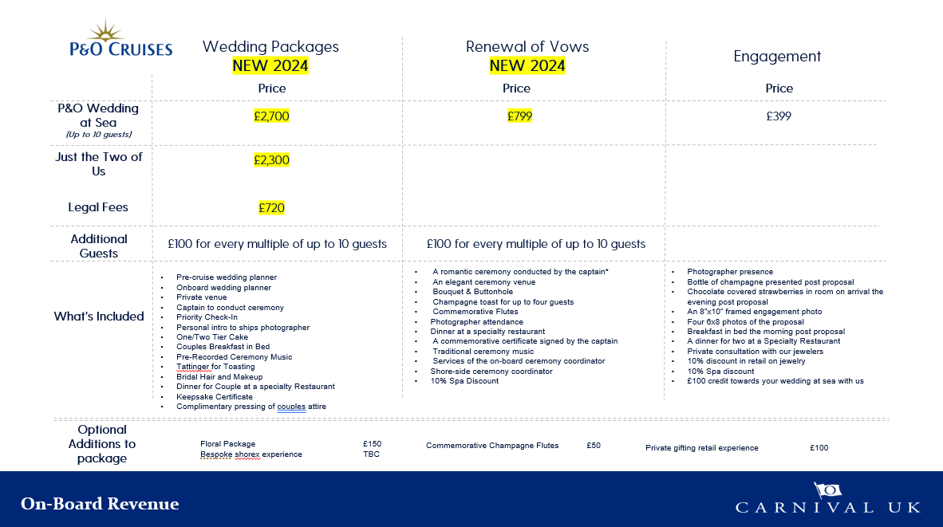

**Cunard:** New 2024 pricing

