**Cabin configuration with cot examples**

**Azura/Ventura**

Inside cabin with 2 cots

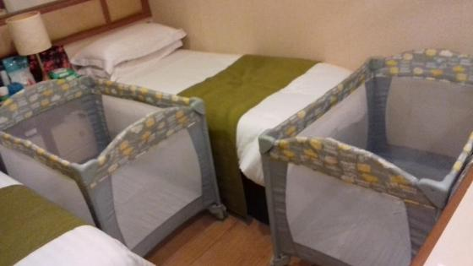

Upper Pullman with cot

